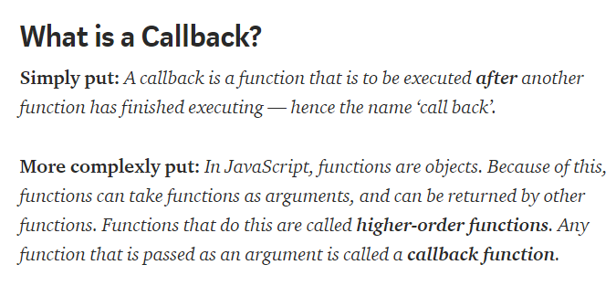

* JavaScript is an event driven language. This means that instead of waiting for a response before moving on, JavaScript will keep executing while listening for other events.

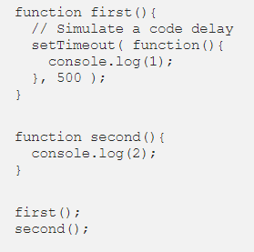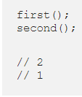

* Even though we invoked the **first()** function first, we logged out the result of that function after the **second()** function. It’s not that JavaScript didn’t execute our functions in the order we wanted it to, it’s instead that JavaScript didn’t wait for a response from **first()** before moving on to execute **second().**